# Servo Motor

A servo motor is a rotary actuator or motor that allows for precise control of angular position, velocity, and acceleration.

**Working Principle:**  
Servo motors work on the principle of feedback. They receive a control signal (typically PWM), move to the desired angle, and send feedback to maintain position. They consist of a motor, control circuit, and a potentiometer for position sensing.

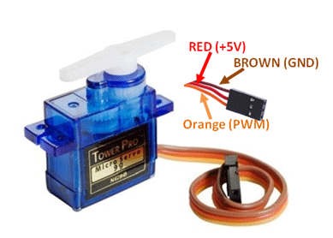 **Types**:  
- Positional Rotation Servo  
- Continuous Rotation Servo  
- Linear Servo

**Applications**:  
- Robotics (arms, joints)  
- RC cars, boats, planes  
- Camera gimbals  
- Automation systems  
- Actuators in embedded systems

**Advantages**:  
- High torque in small size   
- Accurate position control  
- Easy to interface with microcontrollers Fig: Servo Motor SG90 180

**Disadvantages**:  
- Limited range (usually 0°–180°)  
- More expensive than DC motors  
- Requires PWM signal to operate